20th May 2019

**Superb Performance of BMW at the 24Hour Qualifying race**

The starting phase of the six-hour 24h Qualifying Race proved to be a true thriller, with the typical Nordschleife conditions adding to the battle at the front of the field. The dominance of the BMWs M6 GT3 on YOKOHAMA tyres was evident in the ADAC Qualifying Race at the Nordschleife securing all the podium positions.

While the Walkenhorst Motorsport crew – Christian Krognes (NOR), David Pittard and Nicholas Yelloly (both UK) – clinched the overall win ROWE Racing finished second (Jesse Krohn / FIN and John Edwards / USA) and third (Connor de Philippi / USA, Tom Blomqvist / UK and Mikkel Jensen (DK) respectively.

Many teams seemed to have opted for the wrong tyres for the wet track and started into the race on slicks. What offered Marcel Fässler in the Audi R8 LMS #4 the opportunity to shine on his wets, thus clearly outpacing pole sitter Yelmer Buurman in the Black-Falcon-Mercedes-AMG #6 and the rest of the field. His domination however did not last long. On lap four he had to come in for slicks as the competitiveness of his wets dropped on the drying track. After three hours, the BMWs M6 GT3 of ROWE Racing, Schnitzer and Walkenhorst as well as the two Porsches 911 GT3 R of last year’s winners Manthey Racing proved to be particularly competitive.

In the second half of the race, the BMW squads delivered in amazing style. The BMWs temporarily were eight second faster than the Porsches 911 GT3 R behind them and only a 1:32-minute time penalty for having ignored yellow flags made the BMW strategists frown. Record winners Manthey Racing seemed to be on the way to making it to the podium but with just a few more minutes to go they had to pit with steering-system problems – and the one-two-three for BMW was wrapped up.

Norwegian Christian Krognes described the success as follows: “This was one of my most intense moments in 2019. Closing in more and more on your rival represents a massive boost. I quickly realised that we had better grip in the slow sections. Therefore I knew that I should overtake him at the GP circuit. It has been the first win for the team in many years.”

For his part a delighted spokesman for YOKOHAMA Europe expressed satisfaction with the splendid result which enabled the Japanese premium tyre manufacturer to celebrate the weekend’s success, adding “We have worked very closely with the teams and we are really pleased with this outstanding result.”

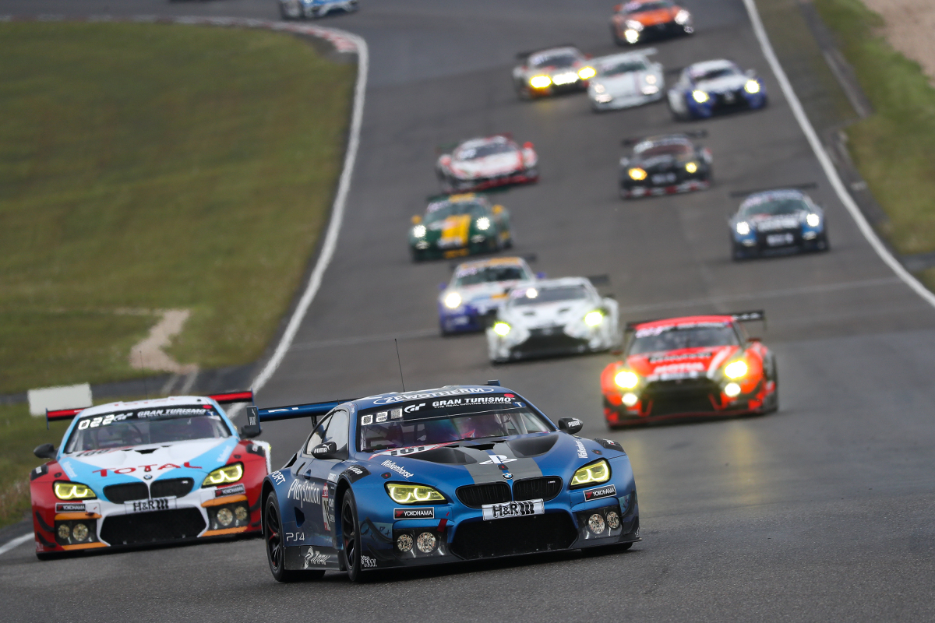

*24Hr Qualifying Race Walkenhorst Win Photo Jan Brucke*